SERIAL COMMUNICATICATION
RS232
RS-232 has been around as a standard for decades as an electrical interface between Data Terminal Equipment (DTE) and Data Circuit-Terminating Equipment (DCE) such as modems or DSUs.
It appears under different incarnations such as RS-232C, RS-232D, V.24, V.28 or V.10 but essentially all these interfaces are interoperable. RS-232 is used for asynchronous data transfer as well as synchronous links such as SDLC, HDLC, Frame Relay and X.25
There is a standardized pin out for RS-232 on a DB25 connector, as shown below
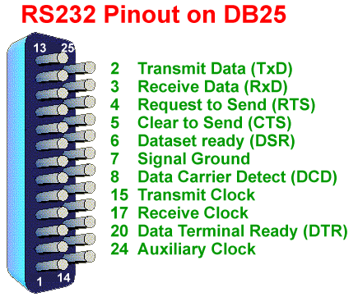
The essential feature of RS-232 is that the signals are carried as single voltages referred to a common earth on pin 7.
Data is transmitted and received on pins 2 and 3 respectively. Data set ready (DSR) is an indication from the Dataset (i.e., the modem or DSU/CSU) that it is on. Similarly, DTR indicates to the Dataset that the DTE is on. Data Carrier Detect (DCD) indicates that carrier for the transmit data is on.
Pins 4 and 5 carry the RTS and CTS signals. In most situations, RTS and CTS are constantly on throughout the communication session. However where the DTE is connected to a multipoint line, RTS is used to turn carrier on the modem on and off. On a multipoint line, it is imperative that only one station is transmitting at a time. When a station wants to transmit, it raises RTS. The modem turns on carrier, typically waits a few milliseconds for carrier to stabilize, and raises CTS. The DTE transmits when it sees CTS up.
When the station has finished its transmission, it drops RTS and the modem drops CTS and carrier together. This is explained further in our tutorial on the SDLC protocol, which uses multipoint lines extensively. The clock signals are only used for synchronous communications. The modem or DSU extracts the clock from the data stream and provides a steady clock signal to the DTE. Note that the transmit and receive clock signals do not have to be the same, or even at the same baud rate.
The auxiliary clock signal on pin 24 is supplied on boards built by Sangoma in order to allow local connections without the need for a modem eliminator. The baud rate of the auxiliary clock is programmable. By jumpering this signals to pins 15 and 17 each side, you can use a simple null-modem cable for synchronous connections. This arrangement is much less expensive that using Modem Eliminator boxes to provide the cable crossover and clocking.
The truth table for RS232 is:
Signal > +3v = 0
Signal < -3v = 1 <-3v>
The output signal level usually swings between +12v and -12v. The "dead area" between +3v and -3v is designed to absorb line noise. In the various RS-232-like definitions this dead area may vary. For instance, the definition for V.10 has a dead area from +0.3v to -0.3v. Many receivers designed for RS-232 are sensitive to differentials of 1 volt or less.
RS-232 is simple, universal, well understood and supported everywhere. However, it has some serious shortcomings as an electrical interface. Firstly, the interface presupposes a common ground between the DTE and DCE. This is a reasonable assumption where a short cable connects a DTE and DCE in the same room, but with longer lines and connections between devices that may be on different electrical busses, this may not be true. We have seen some spectacular electrical events causes by "uncommon grounds".
Secondly, a signal on a single line is impossible to screen effectively for noise. By screening the entire cable one can reduce the influence of outside noise, but internally generated noise remains a problem. As the baud rate and line length increase, the effect of capacitance between the cables introduces serious crosstalk until a point is reached where the data itself is unreadable.
Crosstalk can be reduced by using low capacitance cable. Also, as it is the higher frequencies that are the problem, control of slew rate in the signal (i.e., making the signal more rounded, rather than square) also decreases the crosstalk. The original specifications for RS-232 had no specification for maximum slew rate.
The standards for RS-232 and similar interfaces usually restrict RS-232 to 20kbps or less and line lengths of 15m (50 ft) or less. These restrictions are mostly throwbacks to the days when 20kbps was considered a very high line speed, and cables were thick, with high capacitance.
However, in practice, RS-232 is far more robust than the traditional specified limits of 20kbps over a 15m line would imply. Most 56kbps DSUs are supplied with both V.35 and RS-232 ports because RS-232 is perfectly adequate at speeds up to 200kbps. You may remember the "zero slot LANs" that were popular a few years ago, using RS-232 ports on PCs running at 115kbps. At Sangoma we have successfully used RS-232 (albeit on short cables) at line speeds of over 1.6Mbps.
Interestingly enough, most RS-232 ports on mainframes and midrange computers are capable of far higher speeds than their rated 19.2kbps. Usually these "low speed" ports will run error free at 56kbps and above.
The 15m limitation for cable length can be stretched to about 30m for ordinary cable, if well screened and grounded, and about 100m if the cable is low capacitance as well. Our standard test cable at Sangoma is an interconnected run of round and flat cable, about 25M in length, with no screening at all. We run error free on this cabling collection at up to 112kbps.
One of the 8051’s many powerful features is it’s integrated UART, otherwise known as a serial port. The fact that the 8051 has an integrated serial port means that you may very easily read and write values to the serial port.

If it were not for the integrated serial port, writing a byte to a serial line would be a rather tedious process requiring turning on and off one of the I/O lines in rapid succession to properly "clock out" each individual bit, including start bits, stop bits, and parity bits.

However, we do not have to do this. Instead, we simply need to configure the serial port’s operation mode and baud rate. Once configured, all we have to do is write to an SFR to write a value to the serial port or read the same SFR to read a value from the serial port.

Max 232:

RS-232 Drivers

The typical driver output voltage swing is ±8V when loaded with a nominal 5kΩ RS-232 receiver and VCC = +5V. Output swing is guaranteed to meet the EIA/TIA-232E and V.28 specification, which calls for ±5V minimum driver output levels under worst-case conditions.

These include a minimum 3kΩ load, VCC = +4.5V, and maximum operating temperature. Unloaded driver output voltage ranges from (V+ -1.3V) to (V- +0.5V). Input thresholds are both TTL and CMOS compatible.

The inputs of unused drivers can be left unconnected since 400kΩ input pull-up resistors to VCC are built in (except for the MAX220). The pull-up resistors force the outputs of unused drivers low because all drivers invert.

The internal input pull-up resistors typically source 12µA, except in shutdown mode where the pull-ups are disabled. Driver outputs turn off and enter a high-impedance state—where leakage current is typically microamperes (maximum 25µA)—when in shutdown

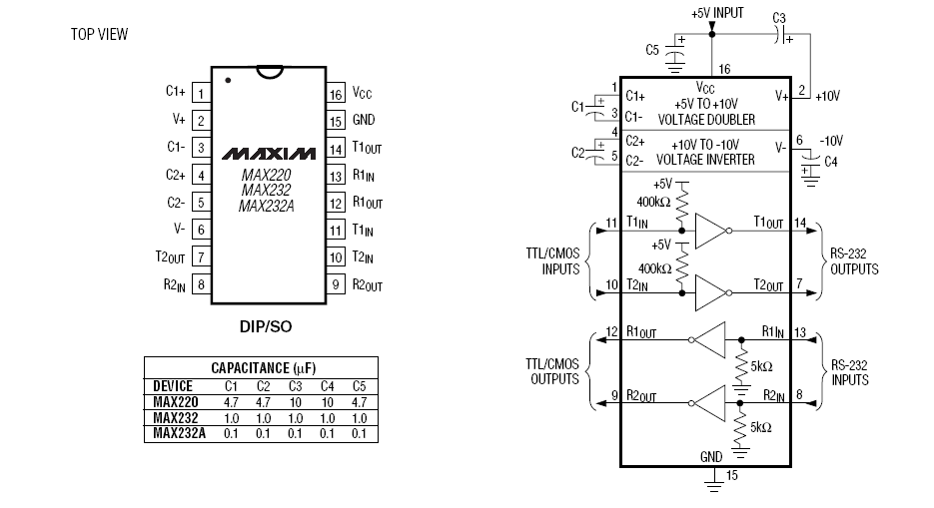

PIN DIAGRAM OF MAX232

